Daily Stand-Up Meeting
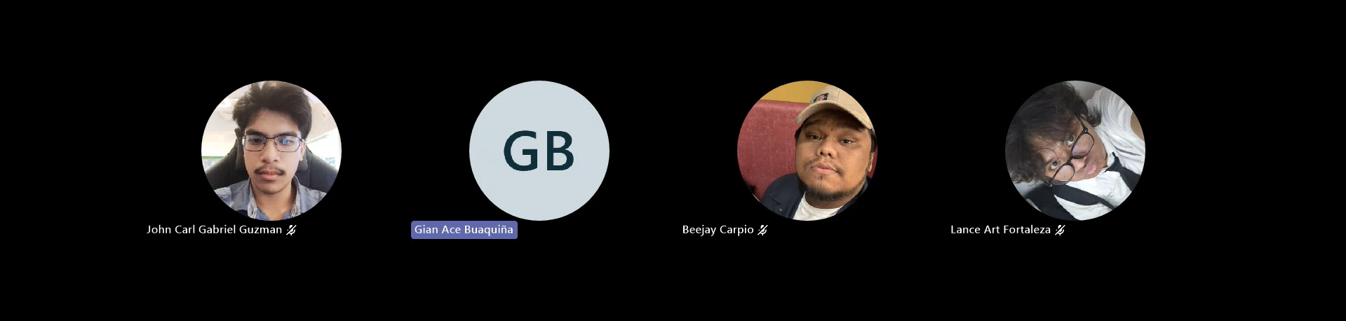
Daily Stand-Up Meeting
Minutes of meeting
Date: 09/22/2026
Meeting Called By: Cache Flow
Meeting Link: Daily Stand-Up Meeting-20260922_155736-Meeting Recording.mp4

Attendees
Gian Ace Buaquiña
Beejay A. Carpio
Lance Art P. Fortaleza
John Carl Gabriel Guzman

Summary
review progress and address key technical blockers. Lance encountered a blocker with Microsoft Entra ID (SSO) login integration due to required admin permissions on APC's Microsoft organization tenant. Gian reported a server host hardware constraint where insufficient RAM memory is affecting the smooth operation of the Koha system. Following Sir Jojo's recommendation, the team plans to visit ITRO on-site to consult Sir Maynard regarding both Microsoft Entra ID tenant configurations and Koha server RAM memory expansion

What we did yesterday
- Beejay A. Carpio: Drafted the Activity Diagram for the student and faculty modules
- Lance Art P. Fortaleza: Attempted Microsoft Entra ID (SSO) login integration for the student interface, hitting a blocker with APC admin permissions.
- Gian Ace Buaquiña: Configured the Koha server environment on Proxmox, encountering a memory allocation blocker due to insufficient host RAM.
- John Carl Gabriel Guzman: Revised and compiled all previous Minutes of Meeting (MOM) covering Sprint 1 progress from Day 1 to Day 6.

What we did today
- Beejay A. Carpio: Drafted the Activity Diagram for the librarian side and work on the ERD.
- Lance Art P. Fortaleza: Prepared ITRO consultation requirements regarding Microsoft Entra ID (SSO) admin configuration for student login.
- Gian Ace Buaquiña: Consulted with Sir Maynard at ITRO regarding Koha server host RAM memory expansion to resolve system performance blockers.
- John Carl Gabriel Guzman: Uploaded the Minutes of Meeting (MOM) for Day 6 and Day 7 and consulted on-site with Sir Jojo and Sir Maynard regarding team technical blockers.

